Weekly Construction Progress Report – Week 23
Harrow Bay Offshore Wind · 01 Jun – 07 Jun 2026
Elena Márquez · 08 June 2026 · HB-PM-RPT-2026-W23

1. Summary
No monopile was installed this week; the total remains 8 of 40. The foundation campaign is 1 pile behind the Rev 2 baseline (9 planned). Waiting on weather amounted to 18 hours.
Area | Status | Comment
Overall schedule | Amber | 8/40 monopiles vs. 9 planned
Foundations | Amber | TPs installed: 8
Offshore substation | Green | Fabrication / load-out
Cables | Green | Manufacturing on schedule
HSE | Amber | Near miss reported

2. Progress
Metric | This week | Cumulative | Plan (cum.) | Variance
Monopiles installed | 0 | 8 | 9 | -1
Transition pieces installed | 1 | 8 | – | –
Waiting on weather (h) | 18 | 161 | – | –
Persons on board (avg.) | 103 | – | – | –
Man-hours MV Sea Atlas | 8,692 | 73,916 | – | –
Lost time injuries | 0 | 0 | 0 | 0
Recordable injuries | 0 | 0 | – | –
Near misses reported | 1 | 3 | – | –
HSE observation cards | 24 | – | – | –

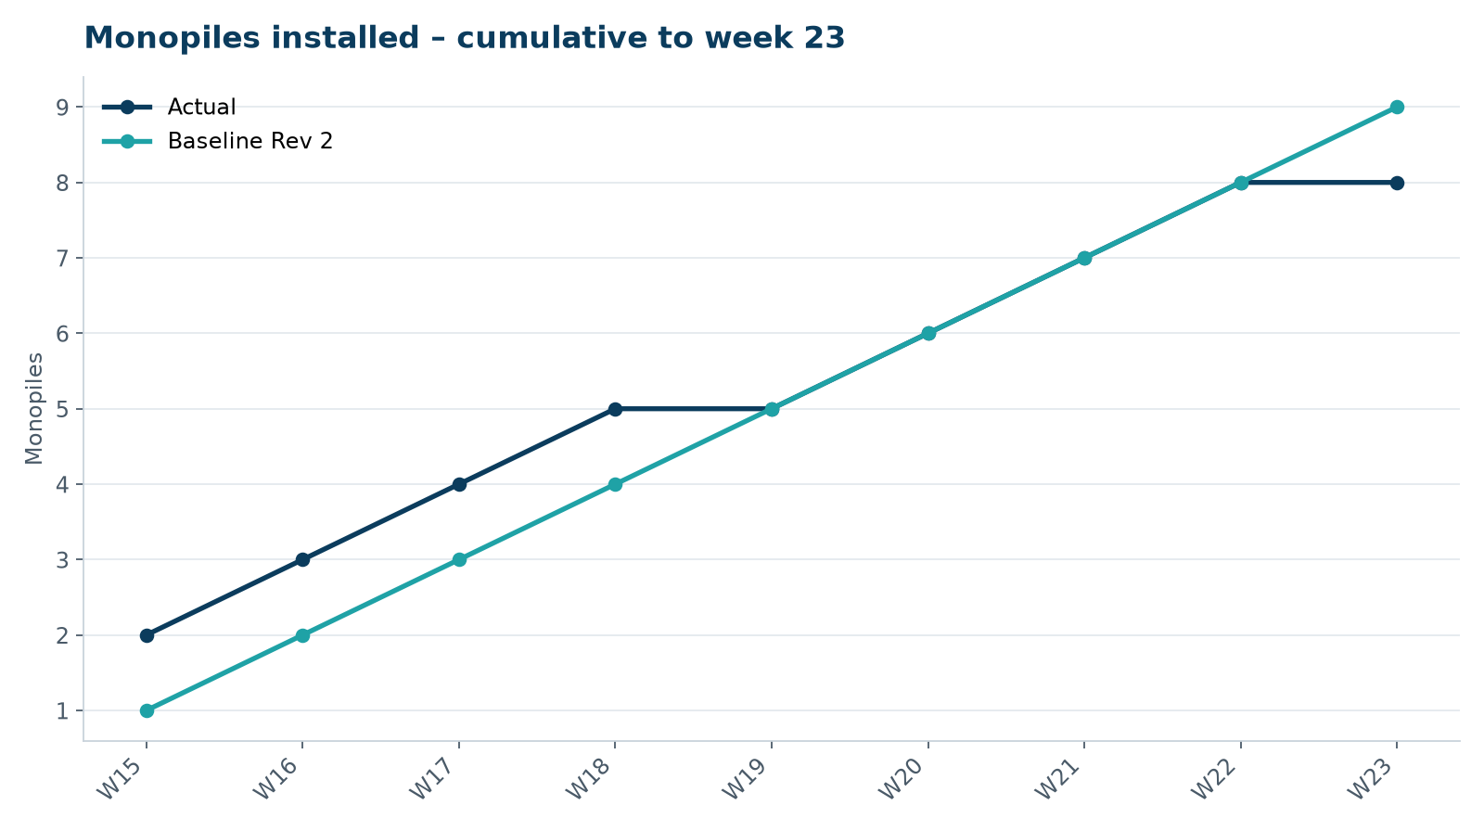
Figure 1 – Monopile installation progress, W15 to W23

3. Key activities this week
- Near miss HSE-INC-2026-018 on 3 June: a 2.8 kg shackle pin fell approx. 18 m from the crane block onto the main deck of MV Sea Atlas during rigging for the HB-A08 transition piece lift. No injuries; the nearest person was 3 m away.
- All lifting operations were suspended for 34 hours; safety stand-down held on all shifts; full DROPS inspection of crane and rigging.
- Transition piece HB-A08 installed on 6 June after the restart was approved by Hannah Weber and the Atlas Marine HSE manager.

4. Health and safety
No lost time injuries. See HSE-INC-2026-018 for the dropped object near miss. 24 observation cards submitted; top theme: access to the TP platform.

5. Environment
- No piling this week; passive acoustic monitoring stations HB-PAM-01 to -04 operational.

6. Issues and risks
- HB-RISK-001 weather: 18 h downtime this week.
- HB-RISK-009 dropped objects – score reviewed after HSE-INC-2026-018.

7. Look-ahead next week
Close out stand-down actions; install HB-A09.
Prepared by Project Controls (Gareth Lewis); approved by Elena Márquez. Distribution: project team, Steering Committee, Halden Turbine Systems, Lenders' Technical Adviser.

